**Question 40 (from 2015 BCC Sem I Exam – WA Test Papers) (12 marks)**

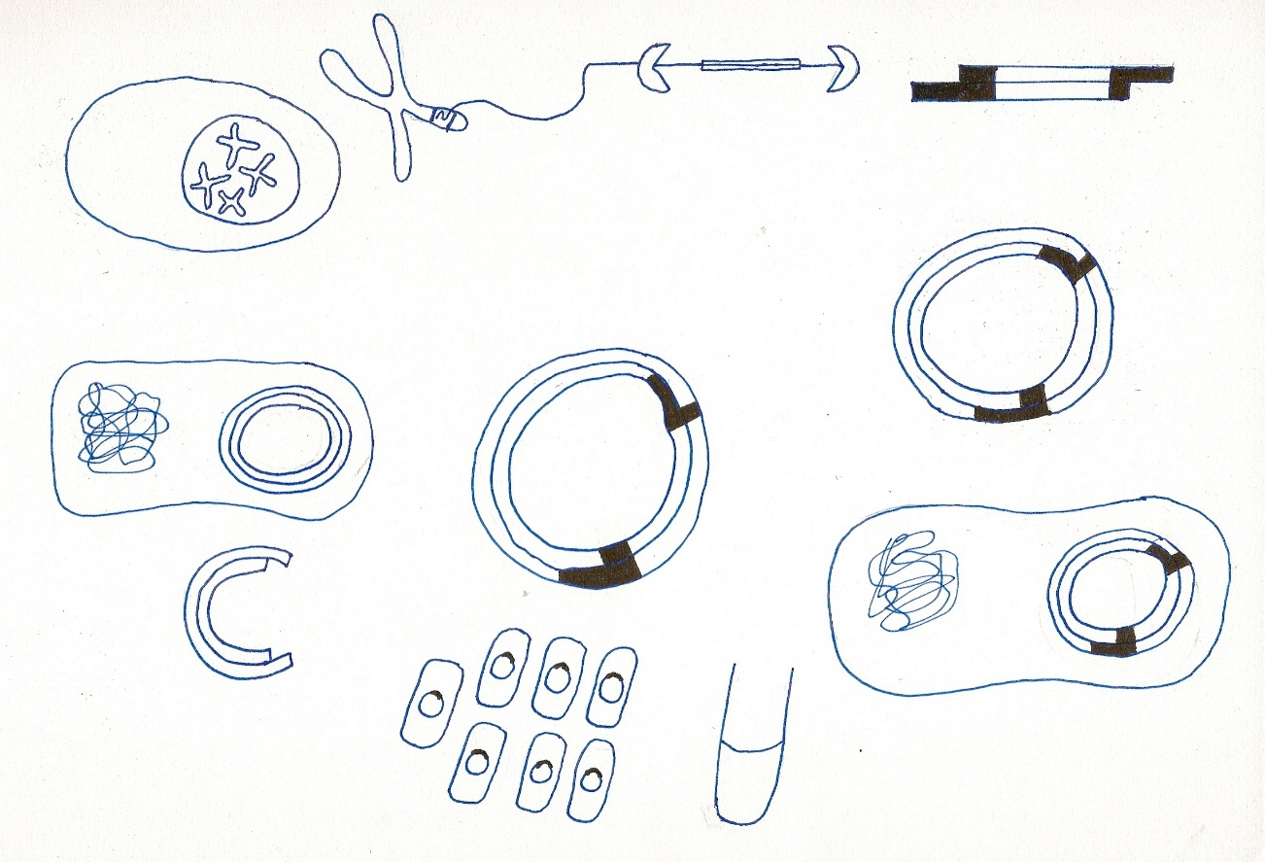

**A**

1. Identify the biotechnological technique in the diagram above (1 mark)

______________________________________________________________________________

1. Name the enzyme that combines the two single strand components of DNA into one single structure in this process. (1 mark)

______________________________________________________________________________

1. Identify structure A and explain how this is essential to this technique. (3 marks)

______________________________________________________________________________

______________________________________________________________________________

______________________________________________________________________________

______________________________________________________________________________

______________________________________________________________________________

______________________________________________________________________________

1. Name one application of this biotechnological technique. (1 mark)

______________________________________________________________________________

1. Describe the steps involved in this process (6 marks)

______________________________________________________________________________

______________________________________________________________________________

______________________________________________________________________________

______________________________________________________________________________

______________________________________________________________________________

______________________________________________________________________________

______________________________________________________________________________

______________________________________________________________________________

______________________________________________________________________________

______________________________________________________________________________

______________________________________________________________________________

______________________________________________________________________________

______________________________________________________________________________

______________________________________________________________________________

______________________________________________________________________________

______________________________________________________________________________

______________________________________________________________________________

______________________________________________________________________________

______________________________________________________________________________

______________________________________________________________________________

______________________________________________________________________________

______________________________________________________________________________

______________________________________________________________________________

______________________________________________________________________________